Distilbert-base-uncased (pretrained model):
DistilBERT is a smaller, faster, and more efficient version of the BERT language model, created by Hugging Face using a technique called knowledge distillation, where a large model teaches a smaller one to mimic its behavior. It retains about 95–97% of BERT’s performance while being 40% smaller and 60% faster, making it ideal for real-world applications with limited resources. Like BERT, it is pretrained on massive text data and can be fine-tuned for a variety of NLP tasks such as text classification, sentiment analysis, question answering, and named entity recognition.
A pretrained DistilBERT model means it has already read and learned from lots of text before you get it, so you can directly use it for tasks like sentiment analysis, emotion detection, question answering, or text classification without starting from scratch.
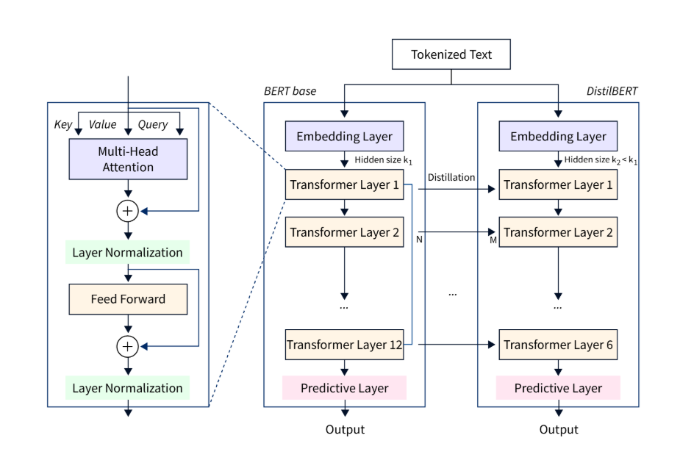
The functioning of the model is explained through an example. When the input text “This makes me angry” enters the model, the first step is tokenization. The tokenizer breaks the sentence into smaller pieces called tokens (for example: [CLS], this, makes, me, angry, [SEP]). Each token is then converted into a unique numeric ID and placed in a sequence. This sequence of numbers is what the model can process. Along with token IDs, additional information like position embeddings (to keep track of word order) is added so that the model knows the context of each token in the sentence.
Next, these embeddings are passed into Transformer layers. Each layer has two main parts: multi-head self-attention and a feed-forward network. In the attention step, every token looks at other tokens to understand their relationships (for example, “angry” is strongly connected with “me” in the phrase). The attention outputs are normalized and passed into feed-forward layers with a GELU activation function, which introduces non-linearity. In DistilBERT, only 6 transformer layers are used (compared to 12 in BERT), but knowledge distillation helps it keep most of the performance while running faster.
Finally, the output from the last transformer layer is sent into the predictive layer (a classification head). This layer takes the contextualized representation of the input sentence and produces raw scores called logits. A softmax function converts these scores into probabilities across the possible emotion classes. For your example, the model assigns the highest probability (≈ 0.996) to the class “anger”. This shows that the model has correctly understood the meaning of the sentence and classified it as expressing anger with high confidence.
Test after fine_tunning:
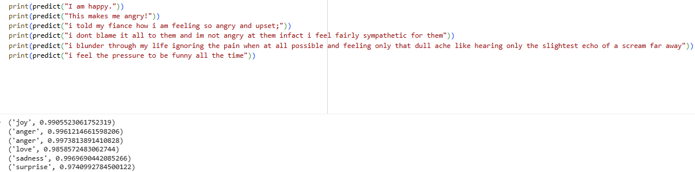
The model successfully classified the input sentences into emotions such as joy, anger, love, sadness, and surprise, each with very high confidence scores (close to 1.0). For example, “This makes me angry!” was predicted as anger with a probability of 0.996, and “I am happy.” was predicted as joy with a probability of 0.990.
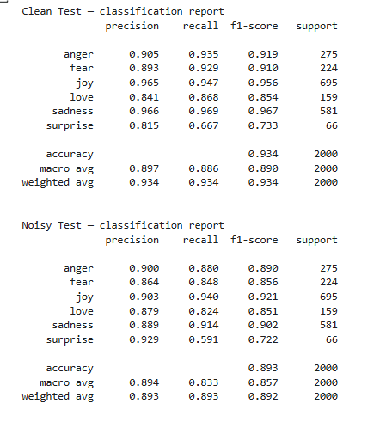
After fine-tuning, the model achieved 93.4% accuracy on the clean test set and 89.3% accuracy on the noisy test set, showing strong generalization even with noisy inputs. The highest performance was for the joy and sadness classes, while surprise was more difficult to classify due to fewer samples.
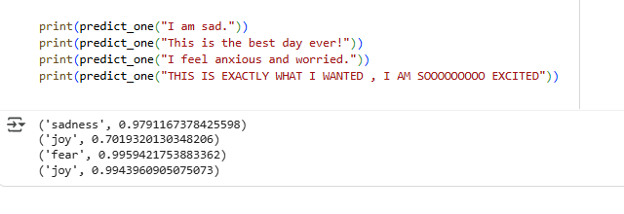
On new data, the model correctly predicted emotions such as sadness, joy, and fear with high confidence, demonstrating its ability to generalize beyond the training set.

